Database HW2 Report

0716211 陳煜盛

**A.**

1. **(3%) What the difference between type “char” and type “varchar”?**

Ans : “char” is fixed length while “varchar” is dynamic length. For example, we declare char(100) and varchar(100), and assign the string “Brian”.The “char” type will hold 100bytes memory to store it, but “varchar” only use 5+2 = 7 to do this.

2. **(3%) Type “boolean” would be stored as which type in MySQL?**

Ans : tinyint(1)

3.**(4%) How many bytes it should take for “tinyint”, “smallint”, “mediumint”, “int”? (e.g. 8 bytes for “bigint”)**

Ans : “tinyint” 1byte, “smallint” 2bytes, “mediumint” 3 bytes, “int” 4bytes

**4.(5%) What do you think about this table schema? If you can change this table architecture, how would you modify it and why?**

Ans : The attribute “version” in match_info is annoying because “version” is a build-in word for SQL syntax. I will modify it to “_version”.

Ans: I think that the number of kills,deaths, … ,pentakills can’t be NULL, it. can be default as 0.

**B.**

1. 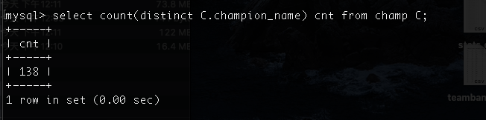

2.

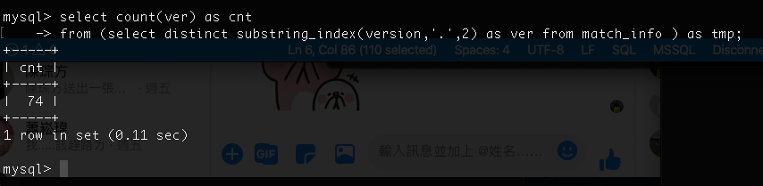

3.

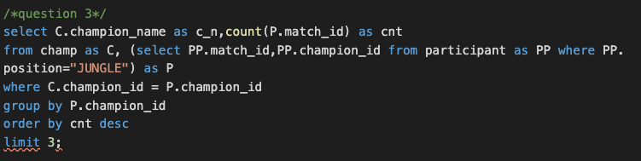

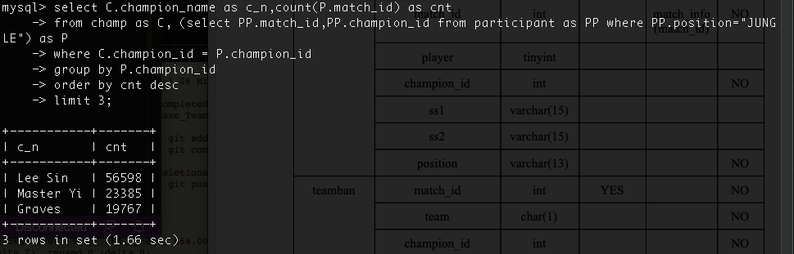

4.

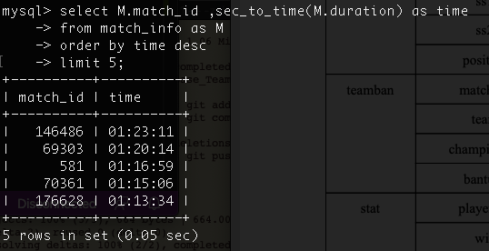

5.

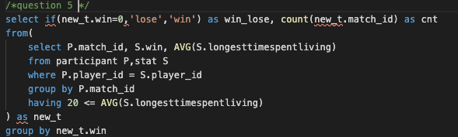

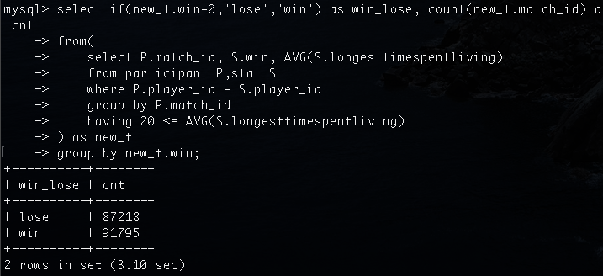

6.

7.

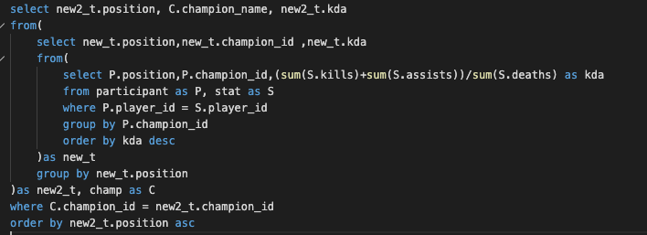

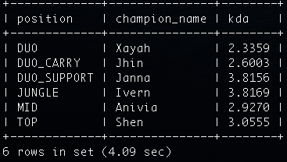

8.

